Premature Optimization – Deliverable 2

Erik Wright (ecwright)

Julian Monticelli (JulianMonticelli)

Brandon Hedges (brandonhedges82)

Tegpartap Singh (teg-singh)

Nathan Davidson (nathan-davidson) — Scrum Master

https://github.com/JulianMonticelli/1530_Premature_Optimization

November 20 2017

Task Network and User Stories

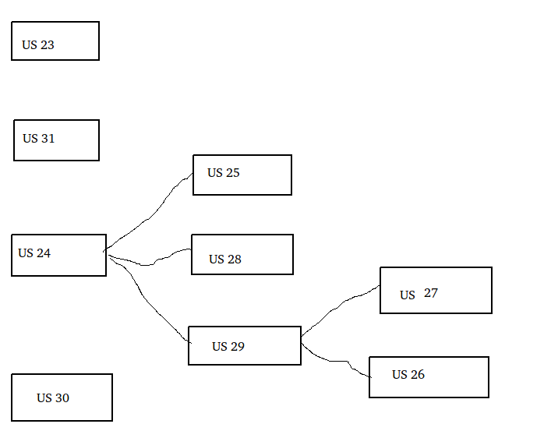

Nathan Davidson: US 29, US 27 (8 points)

Brandon Hedges: US 24, US 25, US 28 (8 points)

Julian Monticelli: US 23, US 30 (9 points)

Teg Singh: US 31 (8 points)

Erik Wright: US 27, US 26 (8 points)

Point Values

US 29 (special move cards), US 27 (special move card movement), US 26 (special move card graphics), US 24 (special spaces): 4 points

US 31 (save and load), US 23 (timer): 8 points

US 25 (random special spaces): 3 points

US 30 (bugfix from previous deliverable), US 28 (static special spaces): 1 point

Visual Tests

We used one visual test, for user story 30 (the bugfix user story).

Visual Test for User Story 30:

Test: Click on the deck until a x2 card is drawn, then click and draw a middle card.

Expected Behavior: The middle card replaces the x2 card.

Observed Behavior (prior to fix): The x2 card display remains, and overlays the middle card.

Observed Behavior: The middle card replaces the x2 card.

Visual Test for User Story 26:

Test: Click on the deck until special move cards are drawn.

Expected Behavior: Special move cards match special spaces.

Observed Behavior: Special move cards match special spaces.